RUN AROUND THE OTTER PONDS
5k Trail Run ☼ 5K Trail Walk ☼ ½ Mile Kid’s Run
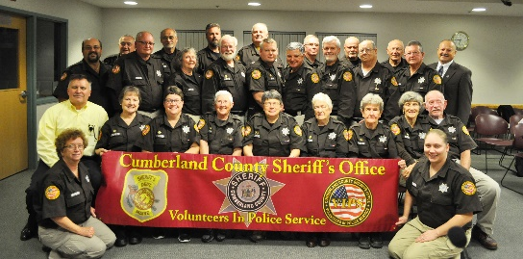 |  |  |  |  |  |  |  |  |  |  |  |  | 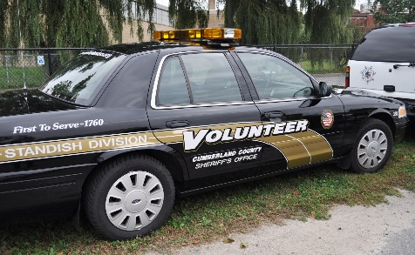
To Benefit Cumberland County Volunteers in Police Services
WHEN |  |  |  |  |  |  |  |  |  | WHERE
Sunday  October 15, 2017  Kid’s Run – 09:00, 5K Walk/Run – 10:00 |  |  |  |  |  |  |  |  |  | Johnson Field  Rte. 35, 89 Chadbourne Rd.  Standish, Maine
☼ T-shirts to the first 100 pre-registered participants ☼
Pre-Register by Saturday, October 14, 2017: Register on line at Michael@3craceproductions.com or mail Registration Form and entry fee to VIPS – 5K Trail Run, 175 Northeast Road, Standish, ME 04084
FEES
 |  |  |  |  |  |  | Pre-Registration Fees |  |  |  |  |  |  |  | Day of Event Registration
Kid’s Run |  |  |  |  |  |  | $5 |  |  |  |  |  |  |  | $7
5K Trail Run or Walk |  |  |  |  |  |  | $20 |  |  |  |  |  |  |  | $25
Family Registration (4 household members) |  |  |  |  |  |  | $45 |  |  |  |  |  |  |  | $50
PACKET PICK-UP ON OCT. 14 BEGINS @ 08:00 – 10:00 am at Johnson Park
AWARDS
1st, 2nd, and 3rd place for overall female and male
First place female and male finish in the following age groups; 12 & under, 13-20, 21-40, 41-60, 61-71, 72 & up
FMI: TWCHRISTIY@ROADRUNNER.COM OR (207) 310-0489
- - - - - - - - - - - - - - - - - - - - - - - - cut here and submit the form below - - - - - - - - - - - - - - - - - - - - - - - - - - -
USE A SEPARATE FORM FOR EACH PARTICIPANT’S REGISTRATION
Name: |  |  |  |  |  |  |  |  |  |  |  |  |  | Age: |  |  |  |  | Gender:
Address:
City: |  |  |  |  |  | State: |  |  |  |  |  |  |  |  |  |  | Zip Code:
Phone: |  |  |  |  |  |  |  |  |  |  | Email:
CHECK CORRECT COMBO: |  |  |  |  |  |  | Pre-Registration Fees |  |  |  |  |  |  |  | Day of Event Registration
Kid’s Run |  |  |  |  |  |  | $5 |  |  |  |  |  |  |  | $7
5K Trail Run or Walk |  |  |  |  |  |  | $20 |  |  |  |  |  |  |  | $25
Family Registration (4 household members) |  |  |  |  |  |  | $45 |  |  |  |  |  |  |  | $50
T-SHIRT SIZE: Adult - S M L XL Youth - S M L
WAIVER
I know running or walking in a road or trail race is potentially a hazardous activity. I should not enter, run or walk unless I am medically able and properly trained. I agree to abide by any decision made by race officials regarding my ability to safely complete, run or walk in this event. I assume all risks associated with this event to include falls, contact with other participants, effects of weather, including heat and/or humidity, traffic and/or other conditions known, anticipated or unexpected. I, acting for myself and/or as legal guardian of a minor participating in this event shall hold harmless and absolve the Town of Standish, the VIPS, the Cumberland County Sheriff’s Office and/or the Portland Water District and all of their officers, agents, employees and/or other participants in this program. I hereby agree to defer, indemnify and hold harmless the Town of Standish, the VIPS, the Cumberland County Sheriff’s Office and/or the Portland Water District in such activity in which any claim may arise due to injury to myself or child. I grant full permission of any of the foregoing to use video, tapes, photos, or any other such record of this event for any legitimate purpose. I understand that there will be no refunds for this event.
Signature (participant): |  |  |  |  |  |  |  |  |  |  |  |  |  |  |  | Date:
Signature (guardian): |  |  |  |  |  |  |  |  |  |  |  |  |  |  |  | Date:
PRE-REGISTRATION ENDS 10/14/17. SEND COMPLETED FORMS TO:
VIPS -5K TRAIL RUN, 175 NORTHEAST RD., STANDISH, ME 04084
REGISTER ON LINE AT: michael@3craceproductions.com

